IGDA game accessibility SIG, March 2017
Written by Barrie Ellis, Tara Voelker & Ian Hamilton

Platform level accessibility recommendations
Accessibility matters, for many reasons. These include:
- The human benefit that gaming can bring, access to recreation, culture and socialising
- The business benefit of reaching the significant numbers involved (over 20% of adults in the USA, not even taking into account 8% of males who have difficulty perceiving colors, or 14% of USA adults who have difficulty reading)
- The impact on developers of their vision reaching as many people as possible, and the competitive advantage of tapping underserved demographics that competitors are not reaching
- The innovative new solutions benefitting all gamers that come from tackling different kinds of problems and constraints
- More recently, through CVAA, also legal compliance
Accessibility features on consoles now have a strong precedent set by both Xbox and PlayStation. However, much more could still be done. There are still many possibilities for greater access to existing devices, and consoles still in early stages of development and so unhampered by retrofitting costs have an even bigger opportunity to transform access for people with disabilities.
This document contains a list of potential accessibility considerations and further details on what each of them addresses and entails, covering software, hardware, and games.
Although the list is long and the concept of accessibility may initially seem daunting, the bulk of accessibility is not R&D work. The answers are already out there. Some of the following recommendations already exist on current gaming platforms, some come from other industries, some already exist in individual games, some come from public requests, and some are unique to this document.
Some recommendations relate to CVAA, some do not. There is intentionally no indication of which relate CVAA and which are not, as the recommendations are intended for providing a good experience for as many people as possible, rather than just providing compliance.
While it is unrealistic to aim to hit everything, doing something is better than doing nothing. There are many quick wins to get started with, and every effort taken will reduce unnecessary barriers and increase the number of gamers who can take part.
A proven approach is to have a simple commitment to always moving forward and never back, to each successive release always being more accessible than the last.

SOFTWARE 3
Controller vibration 3
Configurable double-tap and hold 4
System level button remapping 5
Ability to map multiple inputs to the same button 7
Controller assist 8
Touch assist 9
Switch access 10
Allow control by a second user 11
Zoom 12
Distinct or configurable sounds for notifications 13
Color names 14
Do not implement colorblind filters 15
Text to speech 17
Ability for text to speech to read in-game UI 18
Speech to text 19
Ensure default contrast meets minimum standards 20
High contrast mode 21
Text size 22
System font choice 23
Configurable typography 24
Pre-defined chat messages & emojis 25
System level preference for voice chat 27
Predictive text 28
Allow as much time as is needed for text to be read 29
Notification positioning 30
Allow subtitle/caption display preferences to be set at system level 31
Ensure all video players support captions 32
Stereo/mono toggle & left/right speaker balance 33
Voice commands 34
Disable auto-playing elements 35
Easy mode 36
Provide customisable accessibility shortcuts 37
Do not rely on speech / motion / touchscreen alone for any commands 38
Associate accessibility preferences with profiles rather than devices 39
Information and configuration during initial console setup 40
Expose as many system level accessibility preferences as possible to developers 41
Representational avatars / profile pictures 42
Provide well publicised direct route for accessibility feedback on console functionality 43
HARDWARE 44
Enable compatibility with as wide a range of input devices as possible 44
Backwards compatibility 45
Compatibility with hearing aids and headphones 46
Develop modular easily customisable controllers 47
GAMES 49
Require basic common considerations in certification requirements 49
Encourage consideration of broader accessibility guidelines 50
Accessibility information / filtering in the store 51
Accessibility information on packaging 52
Provide direct route for gamers to get in touch with developers 53

SOFTWARE

Controller vibration
Not all games include a toggle at game level, making them unplayable for people with conditions such as RSI/carpal tunnel, where vibration causes physical pain.
It can also be problematic for people who may not have the controller in their hand (might just be there as an authentication controller or the host to other controls), as vibration causes the controller to move, and can also be a strong matter of preference for gamers who don’t face any impairment-related barriers.
A simple solution is to allow vibration to be disabled at a system level, or if possible, the level of haptic feedback to be adjustable. A more advanced solution would be to offer another means of communicating the feedback, for example a system level on-screen icon to show when haptic feedback is being used in a game.
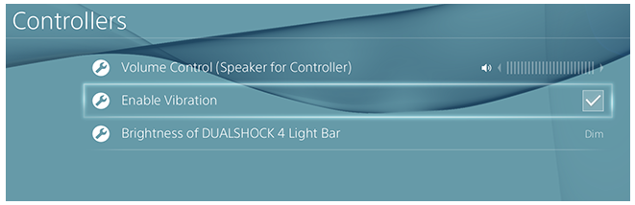
System level vibration toggle on PS4

Configurable double-tap and hold
Offer a less motor-demanding alternative wherever these actions are required, in the same way as being able to configure double-click speed in Windows.
No matter what amount of time you choose, it will always be too difficult for some and too frustrating for others, so being able to configure it allows everyone to operate those core commands in a way that suits their own abilities and preferences. Being able to set up an alternative to having to double tap or hold would also be helpful.

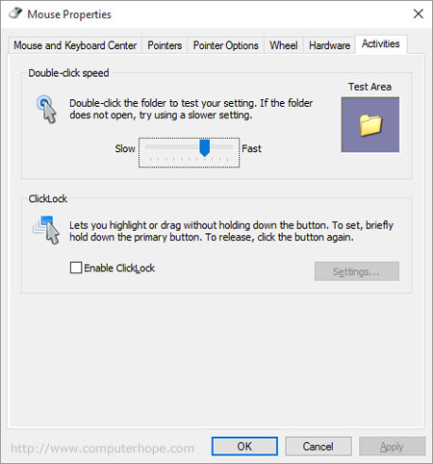
Configurable double-click speed in Windows

System level button remapping
Button remapping is essential for many gamers who are not physically able to reach some areas of the controller, or find some areas of the controller difficult or painful to use.
This is something that should be addressed at a game level. And in previous console generations it has been a certification requirement – no SEGA Saturn game was permitted to launch unless it had full remapping.
However, if in-game remapping is not a certification requirement, including system level remapping can provide a safety net. Ideally allowing full remap of all buttons, including threshold based remap between analogue and digital controls, and allowing mappings to be set on a per-game basis.
It is only a safety net though; it is far better to include at a game level. Game level means better findability (remap is predominantly used by gamers who have no accessibility needs, who are less likely to intuitively think to look in a system level accessibility menu), for flexibility (e.g. separate maps for different classes, as in Overwatch, or for games that have multiple control setups, such as driving and walking in GTA), for the ability for in-game prompts to update to reflect mapping preferences, and for the option of remapping to affect only gameplay rather than menus.
The existing XB1/PS4 remapping has resulted in some developers, even a whole publisher, thinking that remapping is no longer a developer concern. This is harmful, so efforts should be taken to make it clear to developers that system remap is not a substitute for in-game remap, and encouraged to implement remapping themselves. Xbox already consistently give this message to developers.
A test screen would be a useful feature for system level remapping, to allow gamers to test the results of the changes they are making without having to go in and out of a game.
Another useful feature would be to include accessibility options in the list of remap options, for example being able to set up a paddle on the Xbox Elite controller to turn text-to-speech on/off.

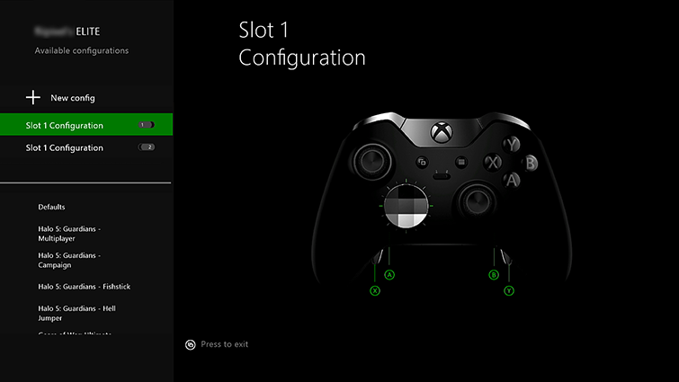
Per-game remapping profiles on Xbox One Elite controller

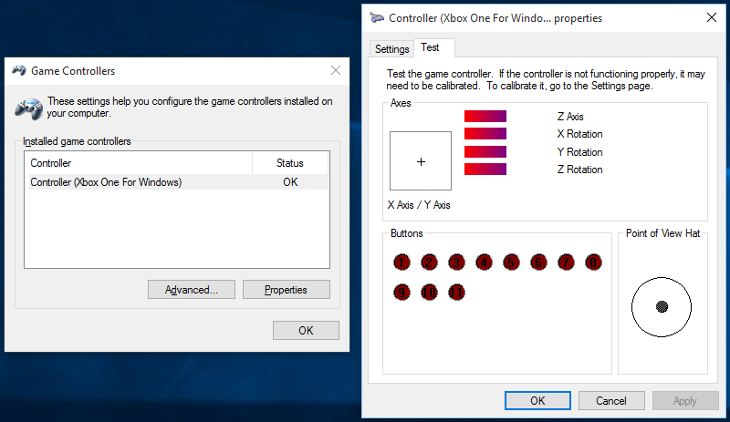
Controller test utility on Windows

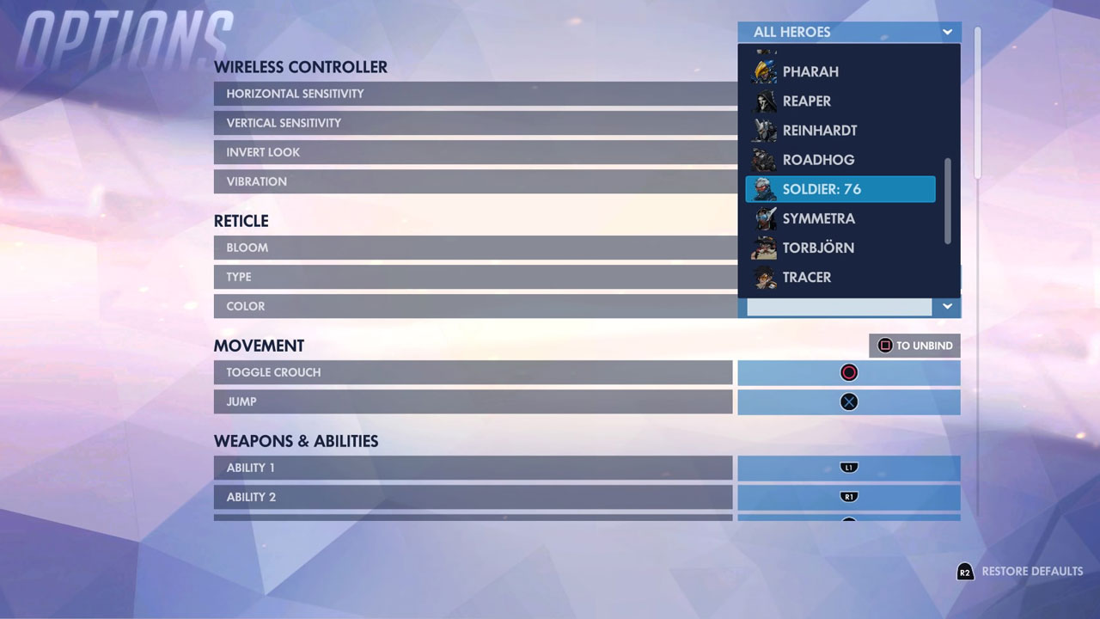
Overwatch allowing separate remapping for each character class

Ability to map multiple inputs to the same button
For some motor impaired gamers, the requirements to press multiple buttons simultaneously can be a significant barrier. For example, pressing two buttons together to execute a throw in a fighting game.
A solution is to allow more than one action to be assigned to a single physical button. For example, console level remap allowing players to assign pressing A to instead register A and X simultaneously.
This gamer is normally unable to execute those kind of complex moves, but has been enabled through flexible remapping:
https://www.reddit.com/r/Overwatch/comments/4kwjfe/thank_you_blizzard_for_allowing_me_to_snipe_for/
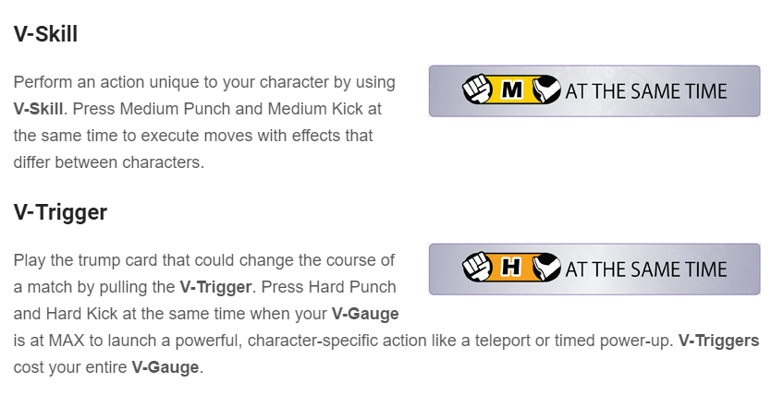
Multiple simultaneous presses required in Street Fighter IV

Controller assist
Provide a menu of controller functions that can be brought up and chosen from at any time – hit a shortcut, then be shown a selectable list of every direction/button on the controller. This enables access for people who are only able to operate a restricted number of inputs on the controller.
At one end of the scale, a game that relies heavily on every button, and a player who can use most of the inputs, apart from lacking the strength to click in L3 and R3. Hit the shortcut button, and choose L3/R3 from the list.
At the other end of the scale, someone who can only operate a single input, but through a combination of the controller assist menu and a switch scanning system (see later in this document), can still play games that have complex controls.
Ideally, to avoid unnecessary motor and cognitive demands, the list should be customisable, containing only the inputs which that player needs to have shortcut access to.
This can currently be done, but through a complex external system running through connected PCs. Operating system level would be far easier for gamers.

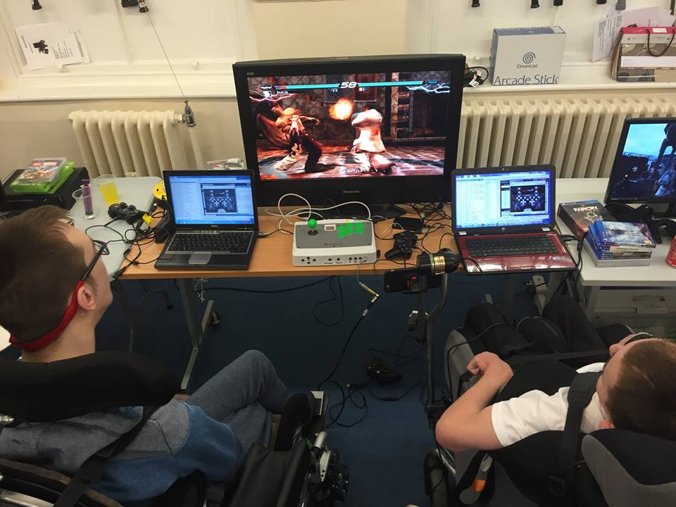
Each player is controlling their Tekken character using only a single button. They can also access all menus.

Touch assist
In the same way as the controller assist described above, allow people who are unable to execute complex or multi-touch gestures on touchscreens to perform them using simple taps, through a predefined menu of possible actions. As with controller assist, it would open up many more experiences than would otherwise be available to someone with limited ability to perform accurate, sustained or simultaneous gestures. Again, as with controller assist, this would be particularly powerful when combined with switch accessibility (see below).

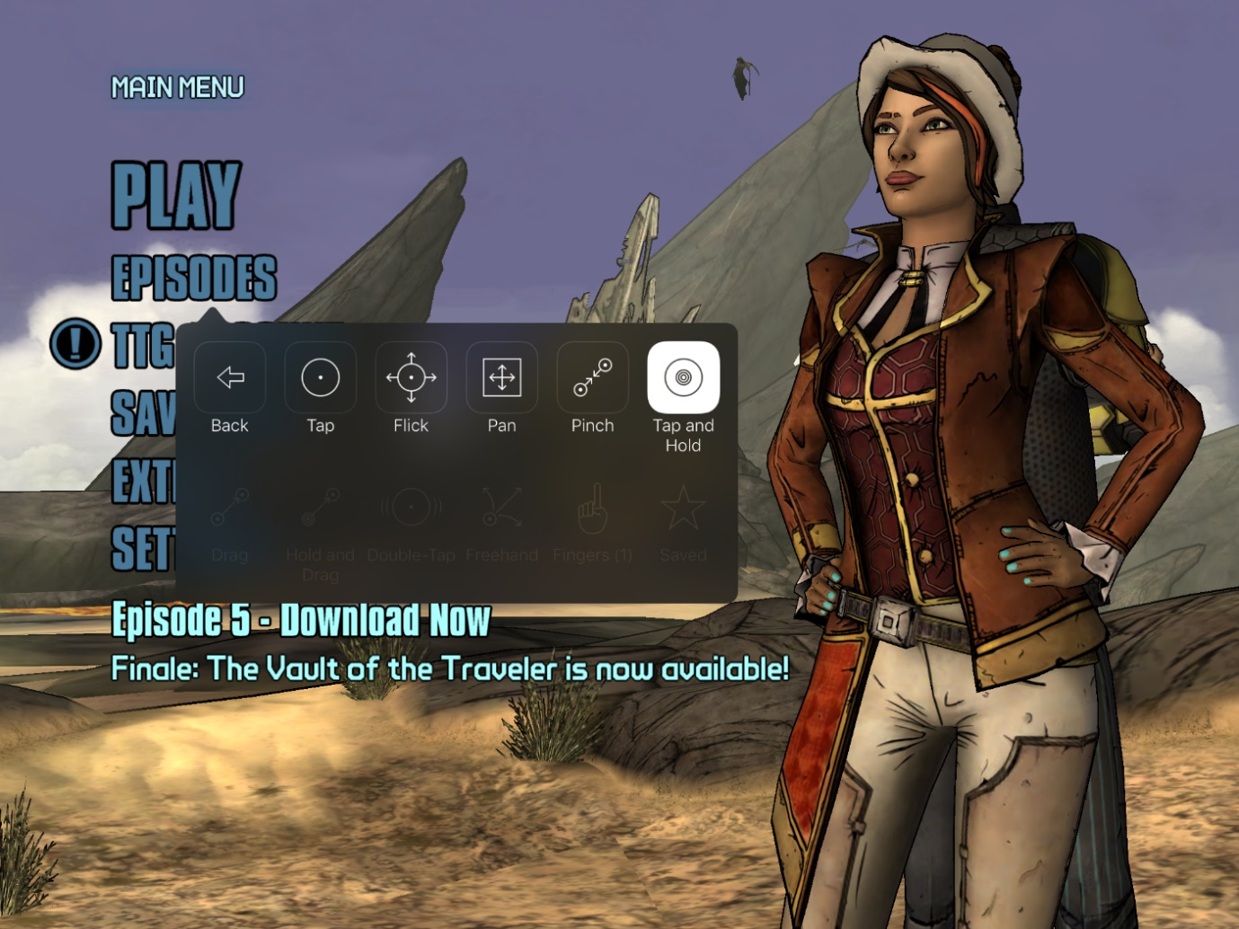
Executing complex gestures with a single press on iOS

Switch access
Switch accessibility means support for Stephen Hawking type technology; using a single input, such as an infra-red blink detector or a headrest mounted single button, to operate the entire operating system. There are a wide range of input devices, from wheelchair headrest buttons to infra-red blink detectors, but they all work in the same way – sending a simple on/off signal, acting as a single button/keypress. The input sometimes registers as an existing controller button, sometimes external Bluetooth devices.
It works through scanning through interfaces, which is essentially focus management. Moving focus around either automatically on a configurable timer (pause for a few seconds on each item, make an input when the one you want is highlighted), or using a second input to cycle manually through the interface elements (both options should be offered). This is built into the operating system of iOS, Android and Macs, and easily achievable through third party software on Windows.
As keyboard/controller focus management is in place, this should be relatively straightforward. It only benefits small numbers, but for those people there is hugely empowering life changing benefit.
There are some configuration options that need to be considered, such as the length of the pause on each item, but this basic level should be easy to achieve. For a more advanced implementation, nesting would be useful, for example navigating a row at a time first, and then navigating within that row. An iOS style point mode would also be useful, crosshairs moving left to right then up and down the screen, allowing selection of elements in games/apps that don’t have exposed native UI.

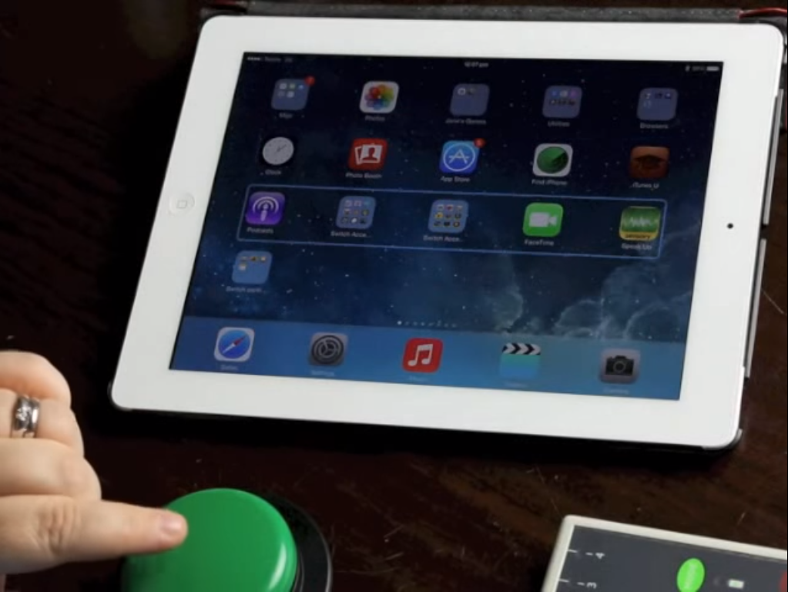
iOS being controlled solely with a single external accessibility switch

Allow control by a second user
A second player jumping in to help isn’t ideal, but it is still powerful safety net for games that aren’t accessible enough for independent play. Particularly valuable is two controllers active simultaneously, as in co-pilot mode on the Xbox. For example, one person steering while a second helps out with acceleration and braking. This would also be essential for someone making use of two controllers as one (e.g. someone using their feet on one and hands on the other).
For this to work well, navigation of the system UI menus should be covered as well as gameplay, and both controllers should be able to be remapped. Additionally, the master controller should be able to disable/enable the secondary controller quickly (e.g. via a shortcut menu). This is very helpful for things like setting up menus or getting through tricky areas with someone who is button-happy.
Also useful would be allowing the second player to take over remotely. PS4’s share play functionality is an example of this. Online communities on PC can be very supportive, with fellow guild members often setting up some fairly intensive support system for disabled fellow player, and allowing this remote functionality could be a good enabler for it.

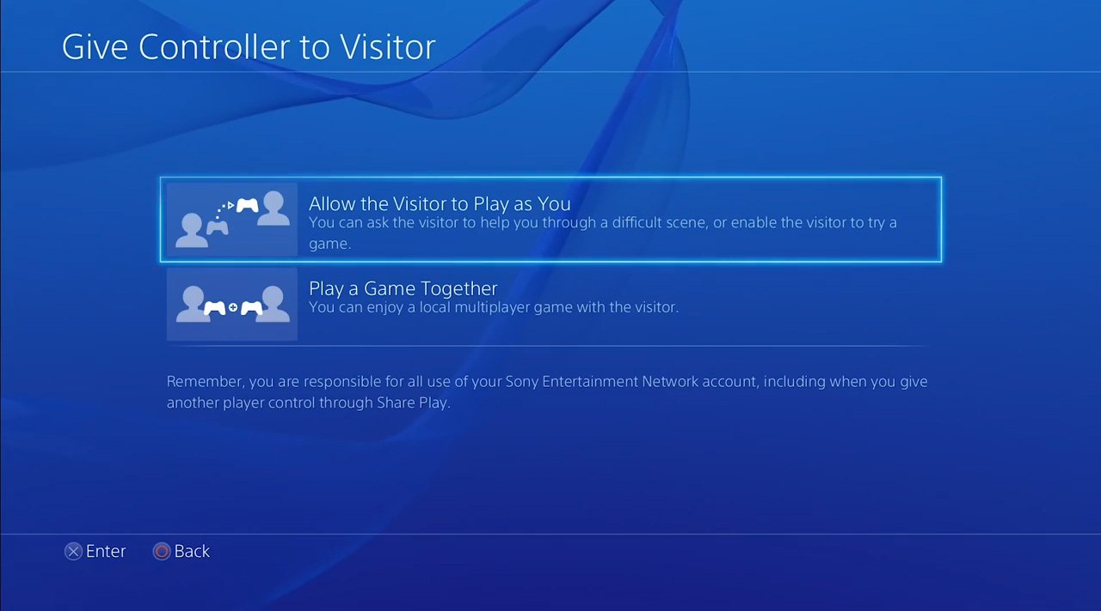
Allowing another player to take over remotely through the PS4’s share play feature

Zoom
Text size is a very commonly commented on issue in games. It needs to be addressed at a game level across the industry as a matter of some urgency (e.g. never dropping below 32px at 1080p), but there will always be people for whom the default size of text, UI elements or gameplay elements is not sufficient. A system level zoom option is an effective workaround, and can also be used to benefit other conditions too, for example to exclude UI elements from view for people who have difficulty with complex interfaces.
This should include the ability to switch between zoom controls and game controls, to allow gameplay while zoomed in. This would be extremely valuable when the text/UI in question is something that involves extensive interaction, such as managing inventory (the screenshot below shows a circumstance in which this would be very useful).
For example, a player uses a shortcut to select zoom. The player then can pan and zoom as much as they please until they hit a button to set the zoom level. At this point, controls revert to game controls rather than zoom controls.
Then, to turn zoom off, use the same shortcut that was used to turn it on. To avoid anyone getting stuck, a notification style prompt permanently on-screen while playing with a fixed zoom level would help, notifying players of how to turn it off.

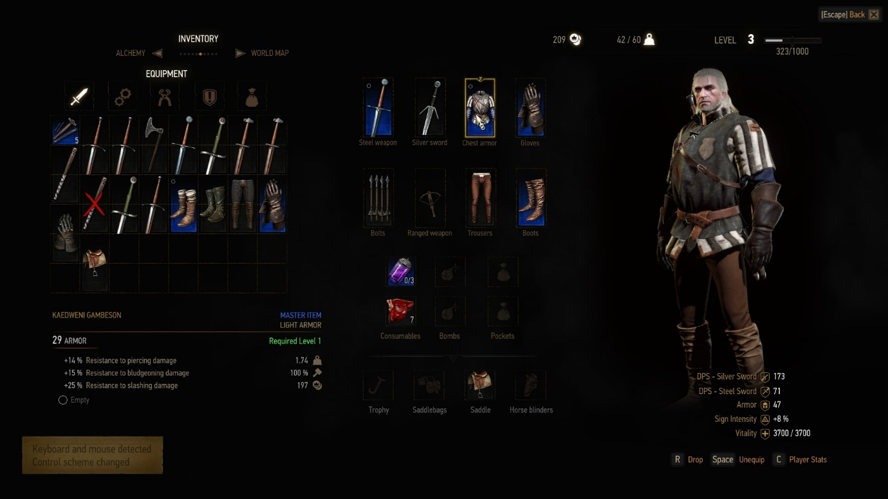
Small text in The Witcher 3

Distinct or configurable sounds for notifications
Provide additional audio cues for people who for vision or cognitive reasons are unable to read the notifications that only appear on-screen for a fixed period. Ideally different sounds for different types of notification, allowing some to be understood without the need to go into the notifications log. This would also mean some added convenience for gamers in general, as there is less need to shift focus from gameplay.

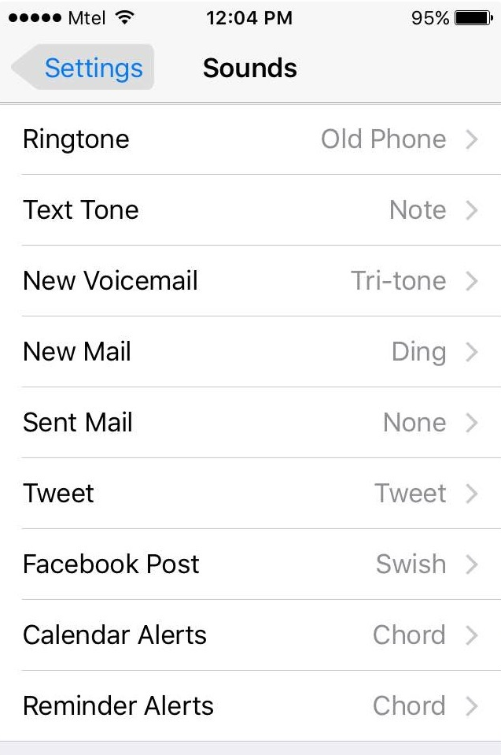
Configurable notification sounds on iOS

Color names
A fairly low impact feature, but one that is easy to implement; add color names to any color based UI customisation options. This would allow color-blind users to know which color they are applying to their interface, i.e. knowing that what they thought was grey-blue is actually bright pink.

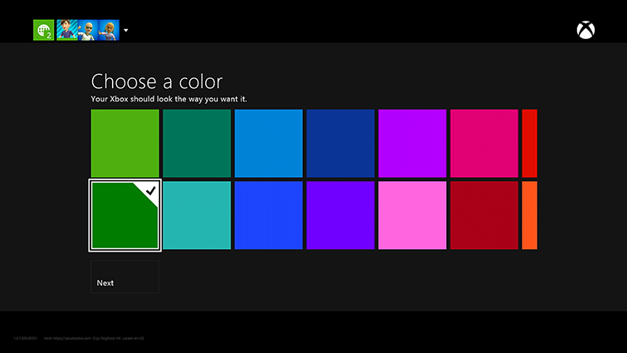
Un-named color choices on the Xbox One

Do not implement colorblind filters
The idea of a single universal visual filter to solve colorblindness is a tempting one, but it does not work.
Pushing hues into areas of the spectrum that are more visible (known as daltonising) has its uses, for example using a daltonising app to tell the difference between a green banana and a yellow banana, but color use in games can be too varied and sophisticated for there to be spare frequencies to shift colors into. Instead, all you can do is bunch hues up closer together.
This means that any kind of shifting (including decent daltonising algorithms) changes colors that do not need to be changed, which can result in taking things that could already be perceived perfectly well, and making them harder to distinguish. Pushing hues closer together, replacing some clashes with others, and unnecessarily harming aesthetics. For example changing all greens to blue – changing grass to a hue that no longer looks like grass, when actually all that needed to be changed was the green team name and minimap marker.
To be effective, colorblind support in games should be implemented by game developers rather than at system level, with the first port of call being to reduce color reliance, using additional signifiers (e.g. symbol/shape). If that isn’t possible, falling back to tweaking individual elements that need to be distinct from each other, such as team colors, ideally offering a free choice of color so that all the various edge case medical conditions can be reached. Some good work has been done to reduce the negative impact of filters, but they still provide no possible way of reaching those edge cases, and are consistently stated by colorblind gamers as not being what they want.
There is an argument that something is better than nothing, i.e. if it helps even a minority of colorblind users in a minority of games it’s still worth having.
However as mentioned previously, system level button remapping has caused some problems, with a major publisher thinking that remapping in games was no longer needed because of it being done at system level. If the same was to happen with colorblindness, with good in-game modes being dropped because of a less useful filter having been implemented at system level, the impact on colorblind gamers would be severe, undoing years of progress.

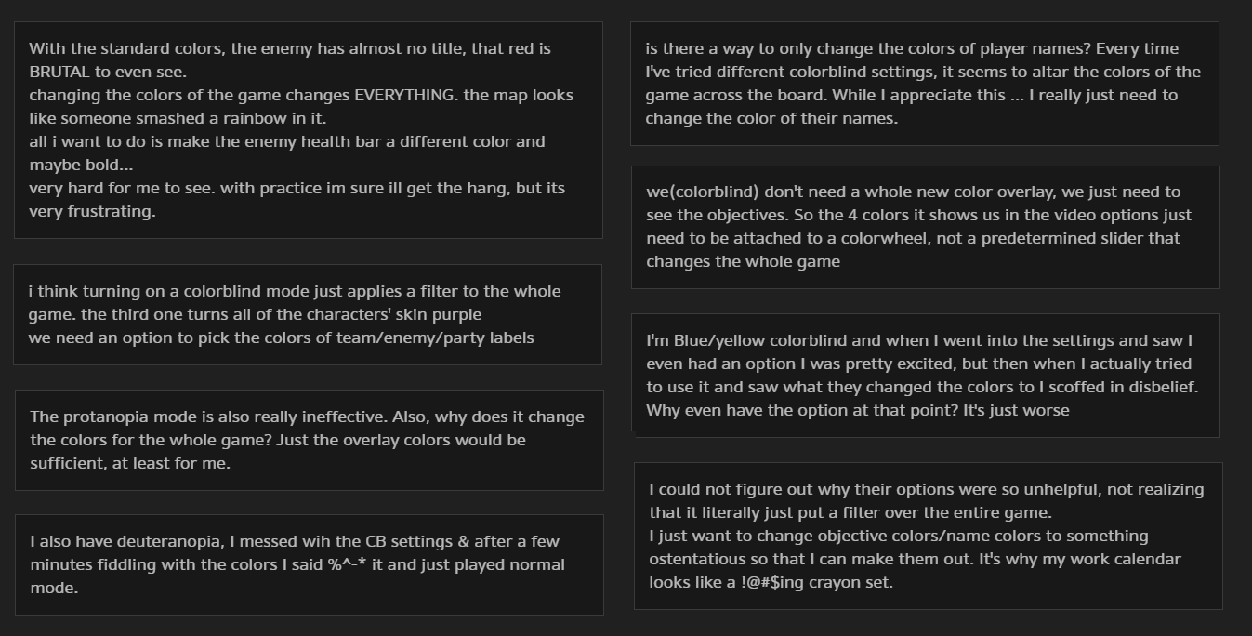
Player feedback on the filter-based colorblind modes in Overwatch
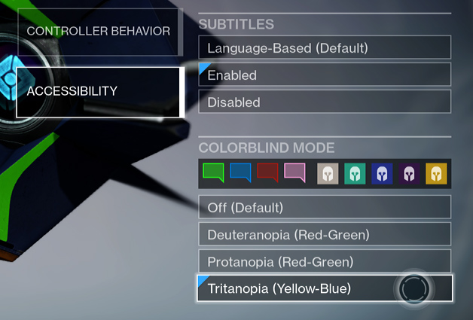
Colorblind support in Destiny, manually designed preset color combinations for important UI elements, while leaving all other visuals intact

Text to speech
The way that blind and low vision users interact with most technology is through synthesised speech reading out the content of the screen. Text to speech is also used by a secondary audience of users who have difficulty reading. There are two aspects to this: firstly the communication itself, and secondly personalisation of the speech.
The communication consists of four elements.
- Focus management, i.e. a way for someone with no vision to physically navigate screens, which is best achieved through digital controls – e.g. keyboard rather than mouse, d-pad rather than moving a cursor using an analogue stick. It should cycle between the elements on the screen. Nesting can be useful for complex interfaces, i.e. navigate between whole groups of interface elements, and when selected, navigating the individual elements within a group.
- Communicating label, type and state of interface elements, for example a button element with a label of ‘next’, an image with a label of ‘man holding a joypad’, a checkbox labelled ‘opt in’ with a state of ‘selected’
- Communicating any changes to onscreen elements that aren’t the direct result of a result of a user action, e.g. a system notification appearing.
The customisation covers such things as choice of voice and choice of speech rate. Many blind users choose a synthetic sounding voice with pronounced syllables to enable them to listen at a very high speed.
Text to speech should be available across markets / languages and cover all of the system UI, including settings menus. Developing a full text to speech system is not a small undertaking, but there are existing third party products – such as NVDA – for which licencing might be possible.
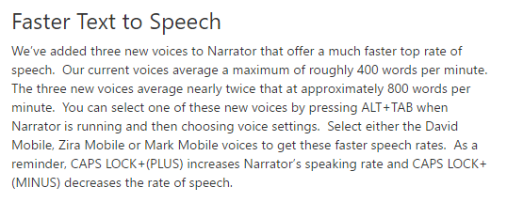
Recent updates to text-to-speech functionality on Windows

Ability for text to speech to read in-game UI
Text to speech for system UI alone has some real benefits, due to the number of non-gaming applications that consoles now support. But opening up a means for it to be utilised in-game would dramatically increase the usefulness of gaming platforms for blind customers. There are currently developers who want to implement accessibility for blind gamers, who have a mechanic that is well suited to it, but are unable to due to the cost and time barriers that result from the output of engines not being compatible with platform level screenreaders.
This isn’t the case outside of frameworks. iOS native app development being a perfect example, it just works. The first that Zynga heard of Hanging with Friends being blind accessible was when CNN got in touch with them about a news story they were writing about it.
There are obviously barriers, firstly needing to collaborate with engine developers, although the climate there is rapidly changing, there are now engines which are expressing an interest. The other being the system resources needed. There’s no way around it though, there does have to be some degree of system provision, developers simply are not willing to take on the cost of doing the work themselves each time when for other devices it is handled at platform level.
A quote from a studio head that summed it up perfectly – “we get requests all the time. I would love to implement it, but we simply can’t justify the cost of building it ourselves. If it was something I could just put a developer on for a week and have it work reliably… I would do it in a heartbeat”
Middle-ground is possible, sharing the overhead between the engine and the platform. For example, the engine handling focus management and manually pushing out text strings to the platform, which then only needs to handle synthesis. This is the approach taken by the new Xbox text-to-speech API.
The benefits are not just player facing; a recent example being a game developed for PC that was able to make use of system level text to speech as a stand-in for in-game speech in early stages before voice actors were hired. They later had to spend money for interim recordings specifically for another platform that did not support text to speech.
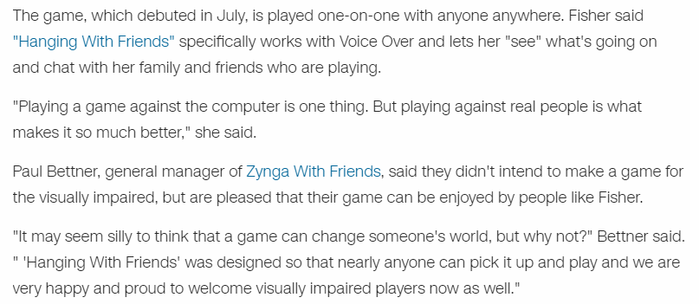
Blind-accessibility for no developer effort, due to dev tool compatibility with OS text-to-speech

Speech to text
Automated transcription for any language based input, for example entering a search term, or communicating with team members.
The ability to freely use either text or speech for communication is obviously relevant to CVAA, however it is often requested by people across the gaming demographics, outside of accessibility.
Technology is currently not advanced enough to provide accurate speech to text in a regular game environment, due to the emotion, gaming specific slang and game specific slang involved. However even early versions of text to speech technology are worth making available, such as the Xbox text <-> speech transcription for multiplayer chat debuted in Halo Wars 2. It still allows a way in for friendship groups who know they need to speak in an understandable way.
Another useful stopgap is to require, at a platform cert level, that both text and voice chat must be included at a game level.
Even in fast paced games where typing is less practical, free text is still very useful in lulls in gameplay and in areas such as lobbies, and functionality such as Rocket League and Battlefield’s pre-defined phrases can make text viable even in the most frantic of circumstances. Games such as EVE online and World of Warcraft already have strong community efforts, for example someone serving as an intermediary to manually translate all important team/guild voice chat across to text and vice versa. They just need the options available to be able to do that.

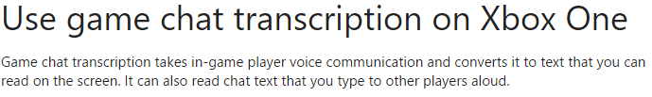
Xbox One platform level text <-> speech transcription

Rocket League providing a free choice of voice chat, free text chat, and predefined text phrases

Ensure default contrast meets minimum standards
There are well researched and established standards for what constitutes a minimum acceptable level of contrast in other industries, which can be applied to gaming, including system UI. Smaller text requires a higher level of contrast. For small text, a contrast ratio of 4.5:1. For large text, a ratio of 3:1.
There are good tools available to check for this, for example https://snook.ca/technical/colour_contrast/colour.html

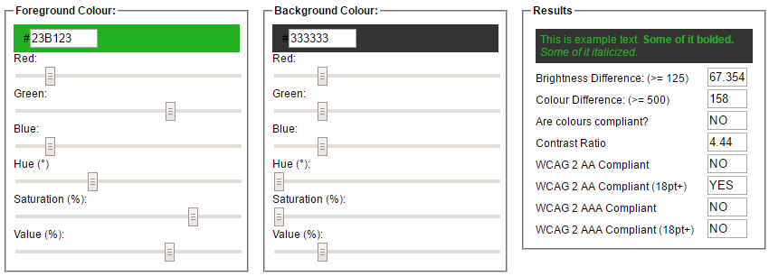
Snook contrast checker, showing 4.4:1 colors that have enough contrast for large text, but not small

High contrast mode
While a good default goes a long way, there will always be people for whom it will not be enough. This includes people with permanent vision impairment, but also includes temporary and situational impairment such as playing in a sunny room. Others still have more specific contrast requirements, such as people with cataracts who need dark backgrounds due to diffraction/glare encountered from bright lights drowning out interface elements.
Ideally provide a selection or configurable colours, but at a minimum offer a single mode with very high contrast, achieved through design rather than a filter. This functionality is particularly powerful when combined the option to increase text size.

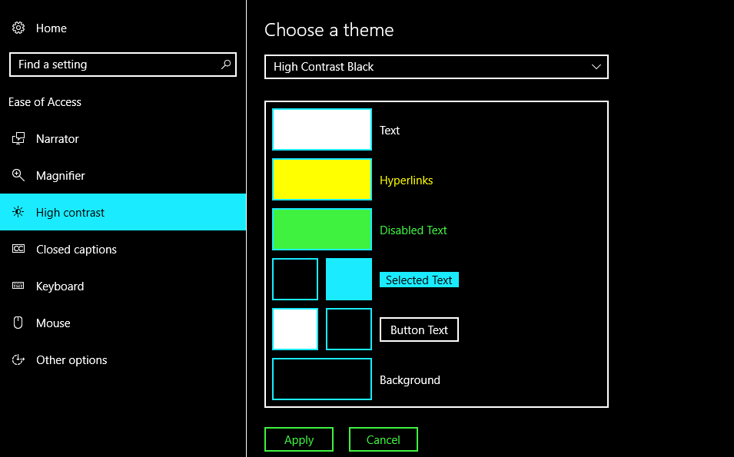
Choice of preset high contrast modes in Windows, with the option to configure each individual color

Text size
Text size is an extremely common accessibility complaint. Control over text size is common on other platforms, and is now starting to be seen to a limited extent on consoles.
However default text size also needs addressing, ideally adhering to a minimum of 32px @ 1080p (46px for text that appears for a limited time, such as subtitles/captions), particularly if text size is not configurable. Although it is rare, some games (such as Warlock of Firetop Mountain) do offer control over text size, so a system level text size preference could be a good candidate for exposing to developers.

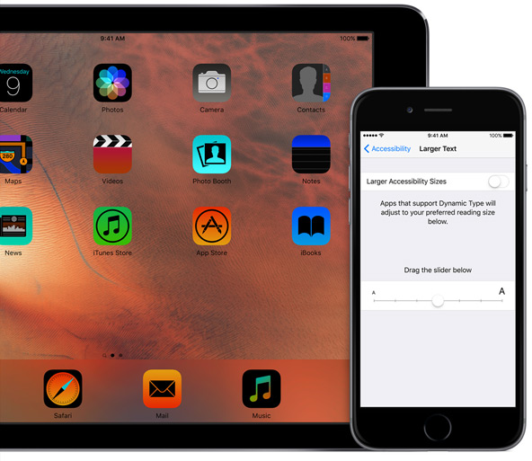
Configurable text size in iOS, reflected in the system UI and apps that support it

System font choice
Difficulty reading is a wide umbrella, and within that dyslexia is also a wide umbrella, covering a range of different symptoms and a range of different fixes. Typography can be a factor, with different typefaces working well for different people. Some have had their lives changed by easy-read typefaces, others need as simple and familiar typeface as possible.
Research into a single helpful solution has therefore understandably been inconclusive. It is most helpful to offer a choice. For example, allow users to choose between an on-brand default, a basic familiar sans serif typeface such as Arial/Verdana, and an easy-read typeface.
Several easy-read typefaces exist, with common themes such as long ascenders and descenders, lack of symmetry between letters, and so on. A particularly notable example is FS-ME, which was developed in conjunction with people with learning difficulties, and has an effective balance of professionally designed type sensibilities and easy-read principles. It was also thoroughly researched and tested by the BBC, resulting in its use as the default font on the YouView set-top box.

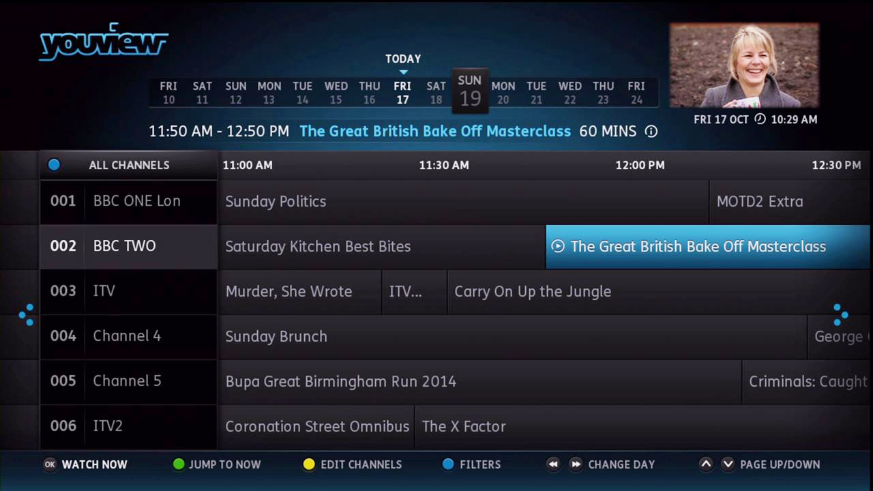
FSME easy-read typeface in use on the YouView set top box

Configurable typography
As well as typeface, other details of typography can make a significant difference to groups under the banner of difficulty reading, particularly where large bodies of text (for example a game description) involved.
The most important is letter spacing, but also important are mixed case rather than full caps, line spacing, use of bold rather than italics, and left-aligned rather than centred or justified text. If any of these cannot be addressed by default (for example 1.5x line spacing), allow them to be configured.

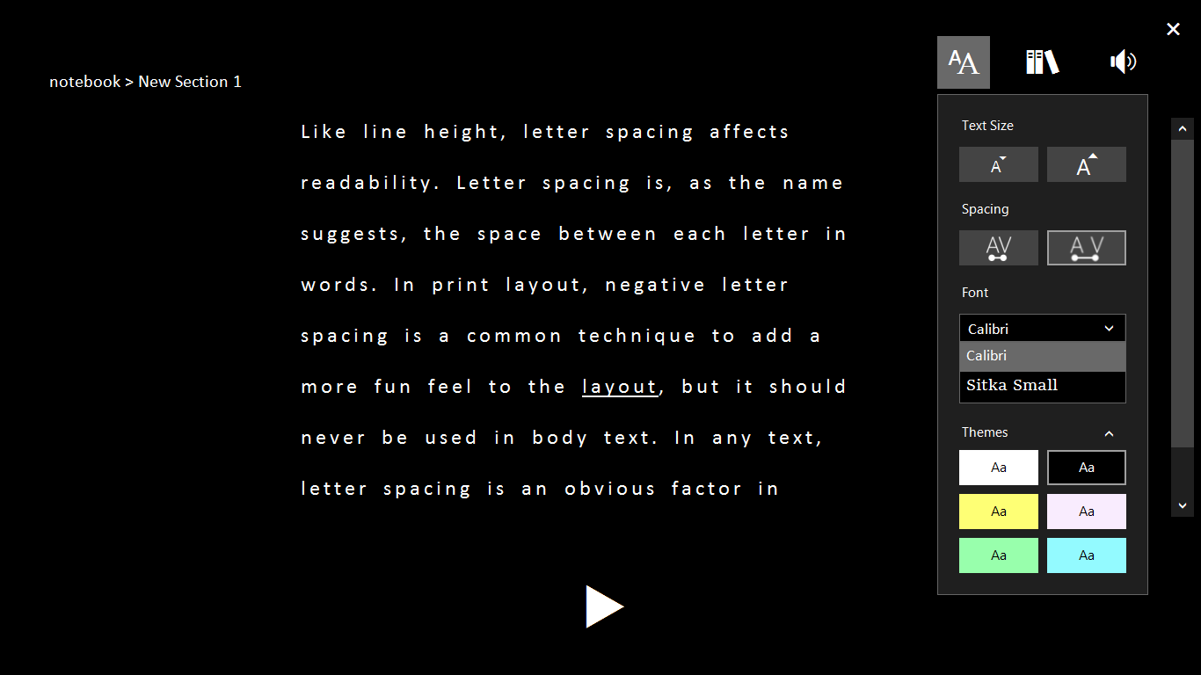
Configurable letter and line spacing in OneNote Learning Tools

Pre-defined chat messages & emojis
Useful for many people, but particularly valuable for people who find typing a difficult, painful or lengthy process, including common ground between impaired motor ability, hearing loss, and impaired speech.
Pre-defined chat and emojis can also cross language barriers, which is why it was implemented in Star Ocean, allowing collaboration between Eastern/Western audiences.
This would be particularly powerful if combined with switch access and speech <-> text.
They can also be combined with other methods of communication, as already shown in Dragon Age 2’s icons attached to conversation options, or Battlefield 1’s simultaneous pre-defined message communicated as both speech and text.
An option to add additional custom messages would be helpful, and the presence of presets would also enable another use case; a parental lock to only allow sending/receiving messages that are constructed from those presets. This is a common approach in online environments aimed at or with a high proportion of children, such as Club Penguin and RuneScape.
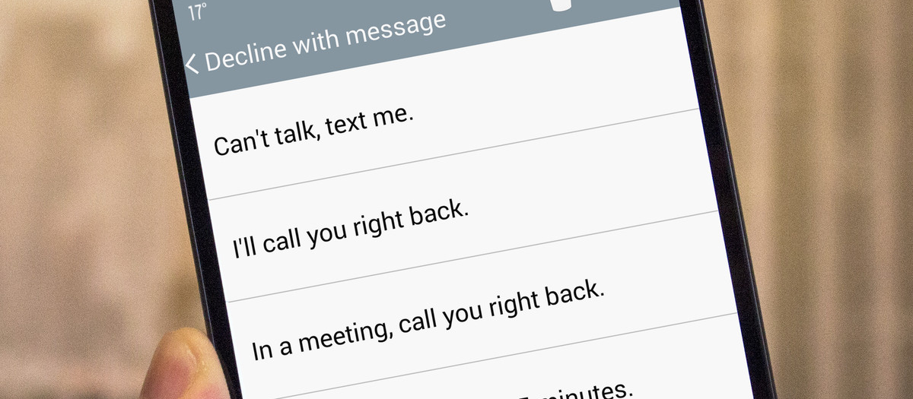
Predefined text messages on Android

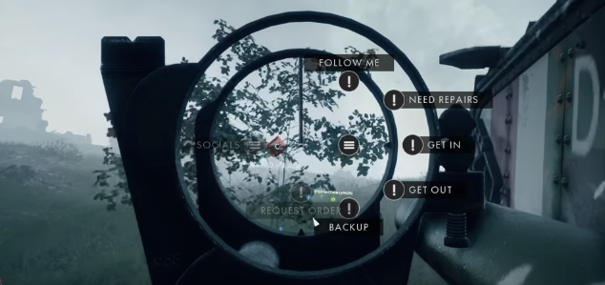
Predefined messages in battlefield 1, communicated as both text and audio
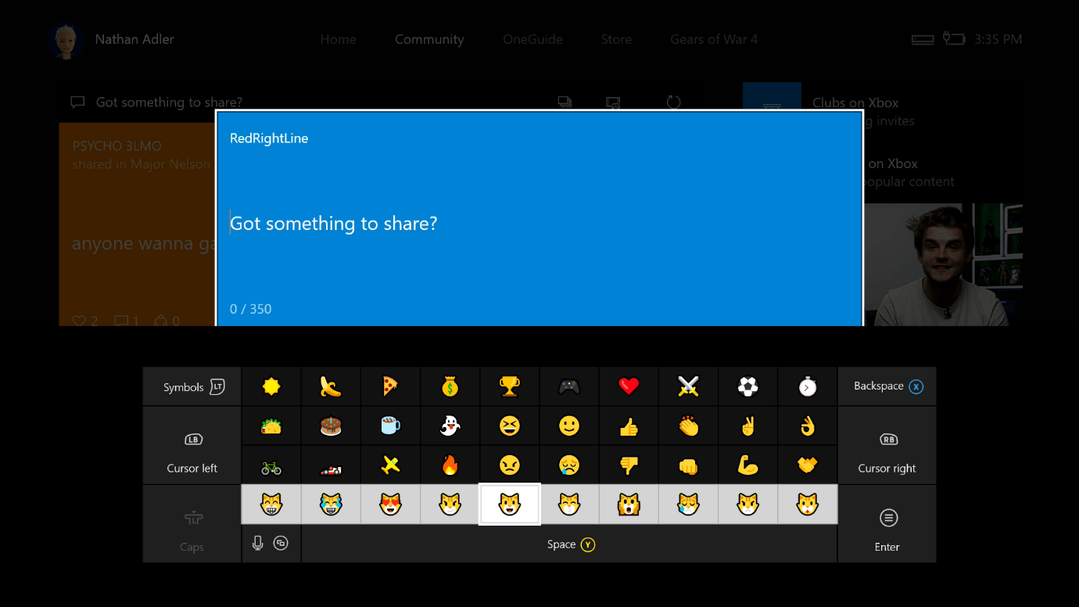
Emojis on Xbox One

System level preference for voice chat
Gamers who do not use voice chat, for reasons of impairment or otherwise, are routinely excluded from online gaming, kicked out by other players.
Text to speech and speech to text are not always an answer, even with the best technology there will be players who are simply not willing to communicate with others, through preference or due to a condition. It is unfair for these people to be kicked out of games, and unfair for players who want to use communication to be forced to play with gamers who do not communicate.
Being able to show other players what your communication preferences are would help. Setting a flag at system level for not wishing to take part in communication would mean that information could then read by developers for use in matchmaking, and communicated in-game through icons on player lists.
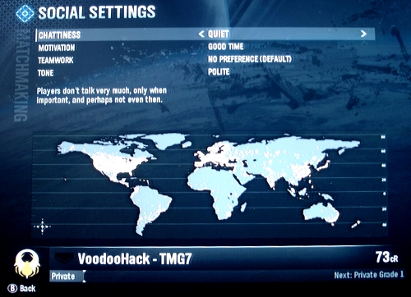
Chattiness matchmaking preference in Halo Reach

Predictive text
Another feature that has very wide benefits; cognitive accessibility for people who have difficulty reading or spelling, permanent motor impairment accessibility through drastically reducing endurance and accuracy requirements, and of course the wide scale situational impairment of the lack of comfort/efficiency of using a controller d-pad or touchscreen to navigate a virtual keyboard.
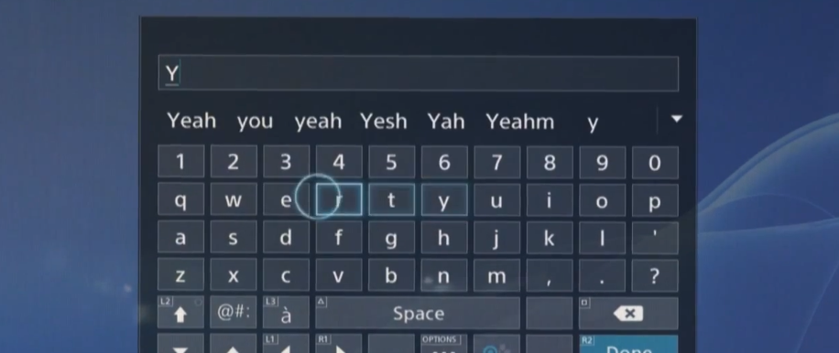
Predictive text on the PS4 virtual keyboard

Allow as much time as is needed for text to be read
Avoid restricting of the amount of time available to read text. If some restriction is unavoidable without impacting the experience for other players, allow a means for those who need to avoid it to reduce or disabled it. For example, if notifications appear for a short period and disappear, allow the period they are displayed for to be configured, and keep a log of them that can be viewed with no time restraints. If text scrolls past on a ticker, allow this to be paused and/or speed configured.
As well as the obvious benefit to people who have difficulty reading, this is again useful for a wide range of reasons - anyone who might have missed a notification through having looked away, been concentrating on a game, temporarily left the room and so on.
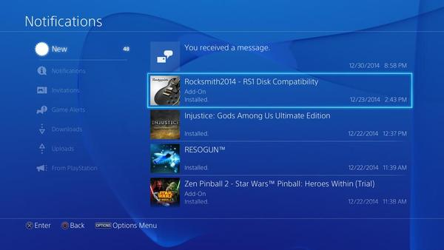
PS4 notifications log

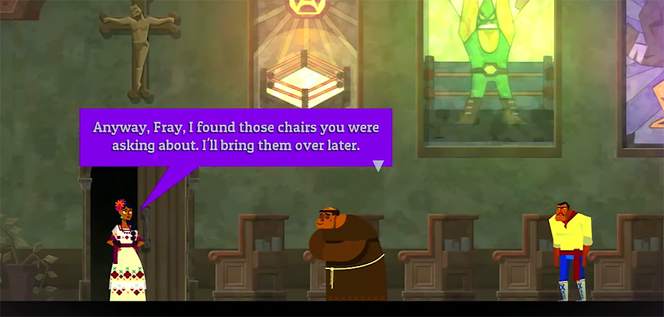
Text in Guacamelee displayed indefinitely until dismissed

Notification positioning
Ensure system level functionality does not interfere with in-game accessibility functionality. An example is system notifications appearing in the bottom-middle, where they obscure in-game subtitling/captioning.
Bottom/middle subtitle positioning is standard across industries, so the notifications need to be positioned somewhere else. Notifications appearing at the bottom-middle can sometimes be game-breaking even for players who don’t have subtitles turned on. For example, Telltale’s games, where notifications obscure conversation choices; choices that a player must read and choose from within a time window of just a few seconds.
Bottom-middle aside, the bottom corners usually have more critical information (i.e. information that needs to be referred to more often) in them than the rest of the screen, so top middle or top corners would be better.
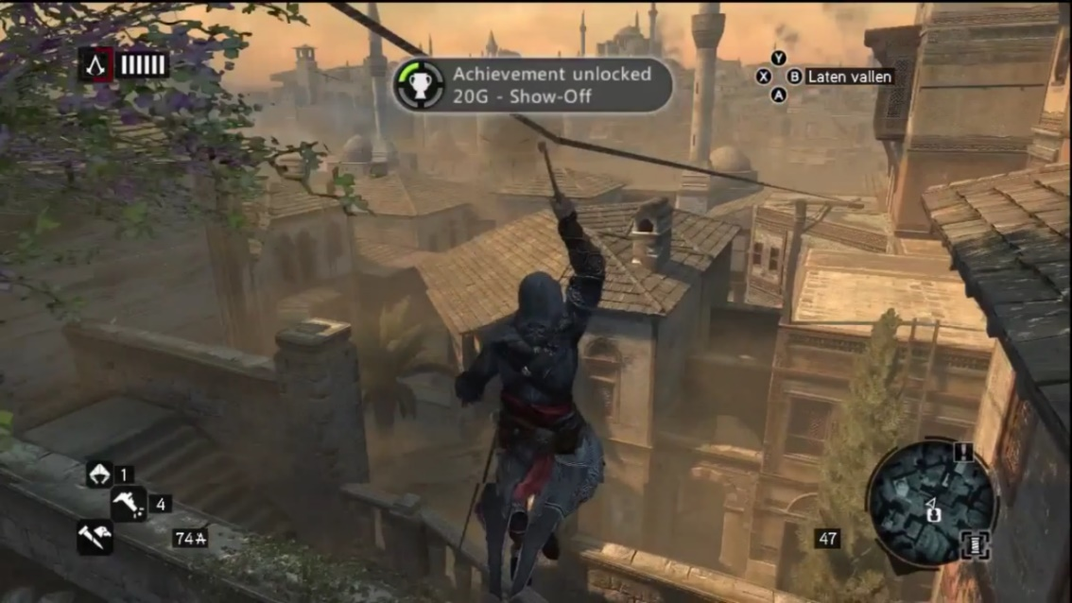
Top-middle notifications on Xbox 360
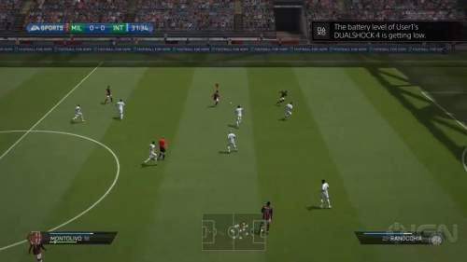
Top-right notifications on PS4

Allow subtitle/caption display preferences to be set at system level
User control over of the presentation of subtitle (text representation of speech, for localisation) and captions (text representation of important audio, for accessibility) is a legal requirement for some videos played at system level, specifically video that falls under CVVA – video that has previously been captioned for television broadcast.
The obvious application for system level preferences is for system level video, such as Blu-ray and VOD. However, it would be ideal for the preferences to also be exposed for developers to pull in as default values for their own in-game subtitles and captions (see “Expose as many system level accessibility preferences as possible to developers”).
There is a standardised set of options defined by VPAAC and backed by the FCC, specced out in a standard called CEA-708 which has been adopted across technologies from smartphones to TV on demand services to games consoles. It requires options for the following:
- Text & letterboxing color override, to white, black, red, green, blue, yellow, magenta, cyan.
- Ability to override font choice with options including monospaced serif, proportional serif, monospaced sans serif, proportional sans serif, casual, cursive, & small caps
- Opacity level of both text and letterboxing, letterboxing from 0% to 100%
- Text size, from 50% to 200% of default
- Text edges, including none, raised edges, depressed edges, uniform edges, and drop shadowed edges
It also requires settings to persist between sessions, and a preview function to be available.
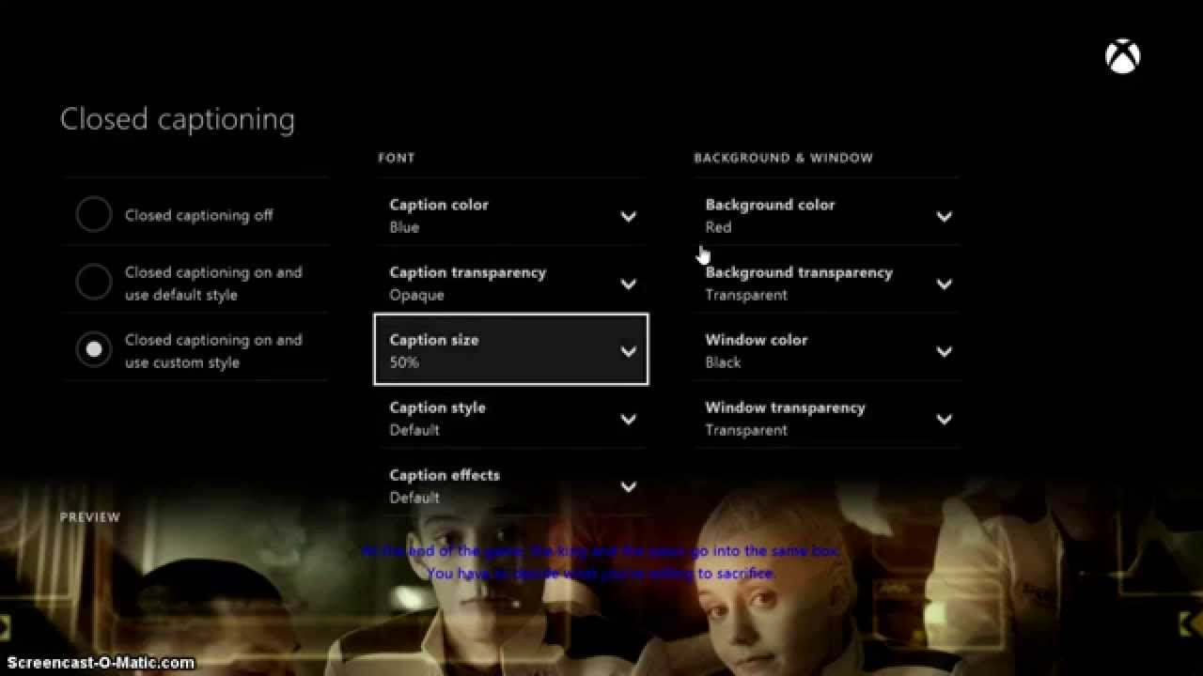
Xbox One caption presentation options, with preview panel

Ensure all video players support captions
Although broadcast video, Blu-ray etc. has functionality to display captions through an associated timecoded text file, other areas of the system often run video players with reduced functionality that do not allow developers or platform holders to add caption files. For example game trailers in the store.
This makes them inaccessible not only people with permanent physical hearing loss, but also temporary and situational impairments such as playing in a noisy room, on mute to avoid waking the baby, or difficulty understanding alien robotic accents on top of a loud music track.

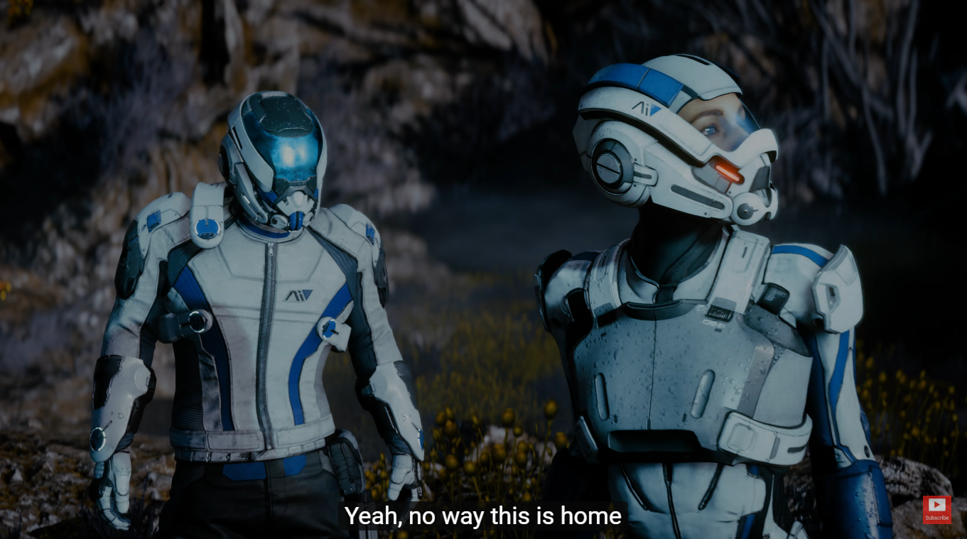
Trailer for Mass Effect Andromeda, with captions displayed through the YouTube player’s captioning functionality

Stereo/mono toggle & left/right speaker balance
Mono output is useful for unilateral hearing loss, but the number of games that provide it is low (Diablo 3 being a notable exception). This is something that should ideally be set at a console level, allowing the audio from all channels to be played equally through all speakers. Speaker balance is also useful, for partial unilateral hearing loss. Both settings are standard functionality on mobile device operating systems.

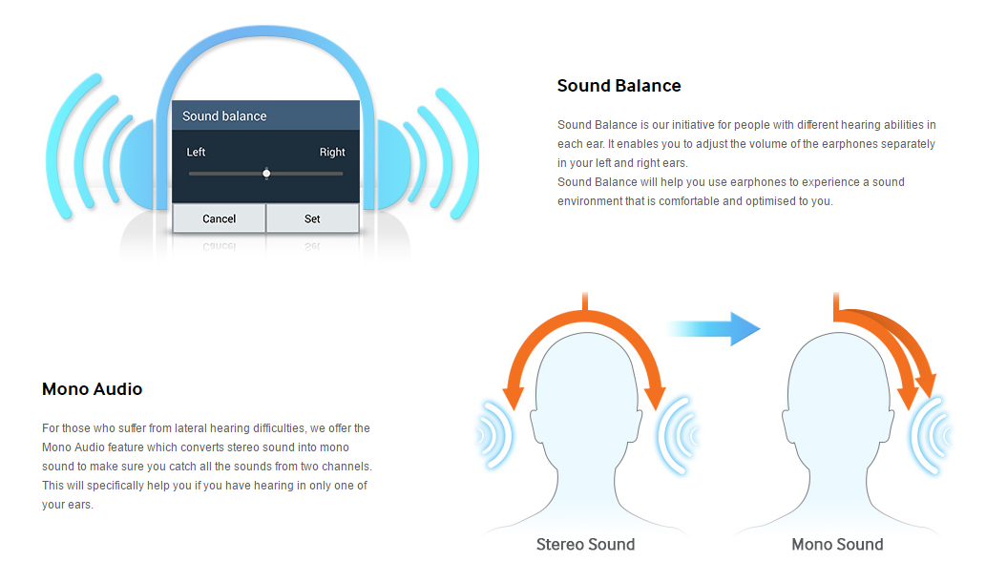
Stereo/mono toggle and left/right balance on iOS

Voice commands
Voice commands, shortcuts for common actions such as opening a game or sending a message, can be very useful for both vision and motor impaired gamers, significantly reducing the burden of navigating menus. However these should be supplementary to other methods of input, and never used as the sole means to access any functionality.

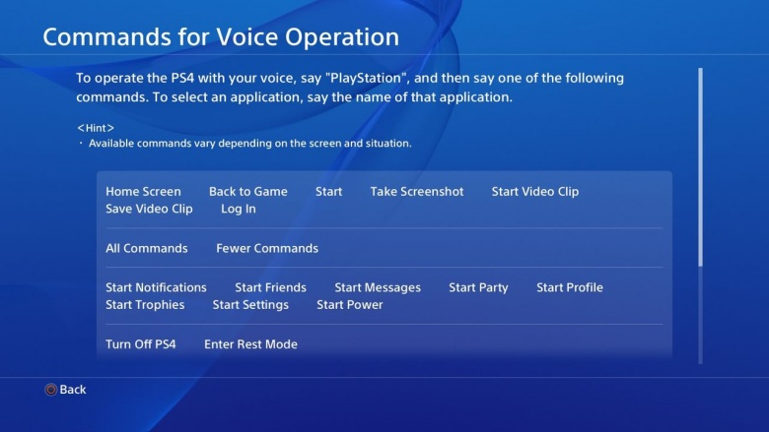
PS4 voice commands

Disable auto-playing elements
Autoplaying video/animation/text scrolling can cause significant problems for people with attention related conditions, such as ADD, or predictability related conditions, such as autism.
This can be achieved either by default or through offering a toggle, with execution working in different ways for different types of element. Freezing until the element is selected, freezing until the element received focus, or even removing the element entirely, for example swapping a video out for an image.
The YouView set-top box offers this exact functionality, a toggle to turn off the picture-in-picture programme guide preview.

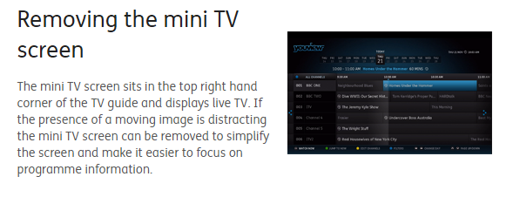
Control over autoplaying video on the YouView set top box

Easy mode
A simpler alternative interface would be great for a wide range of groups. Cognitive impairment, children, even some people with motor or vision impairment would benefit from simpler navigational structure. Access only to the core content items that they need to access, without being able to get lost in menu options that aren’t relevant to them.
The key to this is personalisation. The below example is from Asus’s easy mode, which is a mostly fixed design, but some Doro phones go further and allow any section of the interface to be turned on or off according to the capabilities and interests of each user. iOS has similar functionality, guided access mode allows any area of the interface to have touch input disabled, although in iOS’ case it the disabled areas still remain visible. iOS guided access mode also allows access to be locked within a single game/application, with a password having to be entered to exit out and navigate the rest of the system.

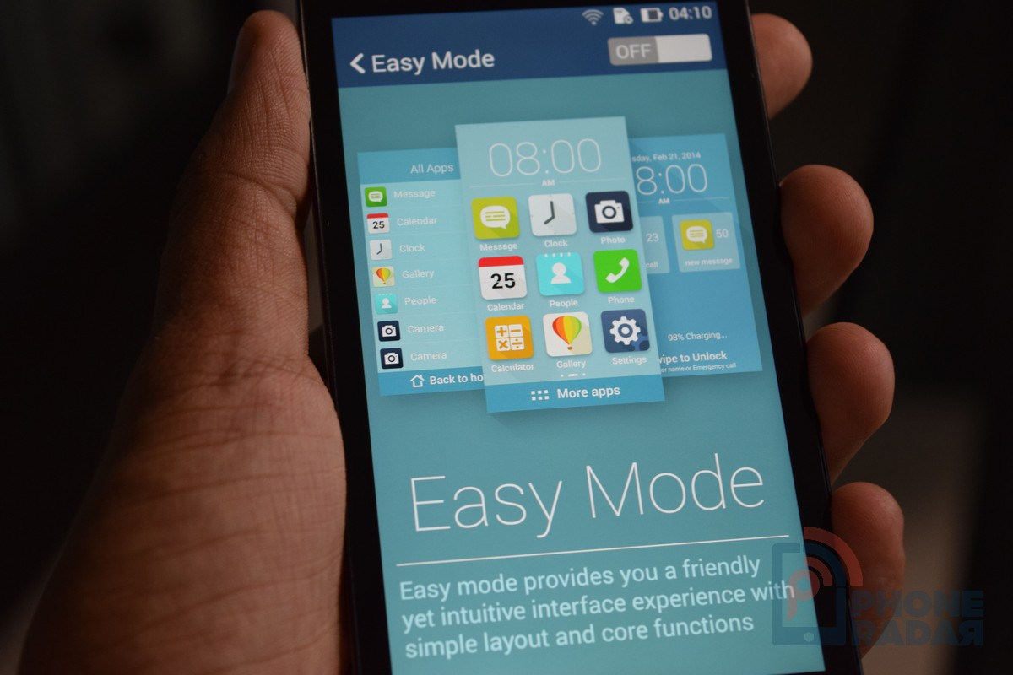
Easy mode toggle on an Asus smartphone

Provide customisable accessibility shortcuts
Different features would obviously be more useful to different people, and menu navigation can be a significant burden for some demographics, so a quick means of accessing the features most useful for a given player is valuable. For example, remap would be a valuable piece of functionality to have a shortcut to, to save the burden of motor impaired gamers having to navigate between menus. A shortcut to the accessibility menu itself would also be useful.

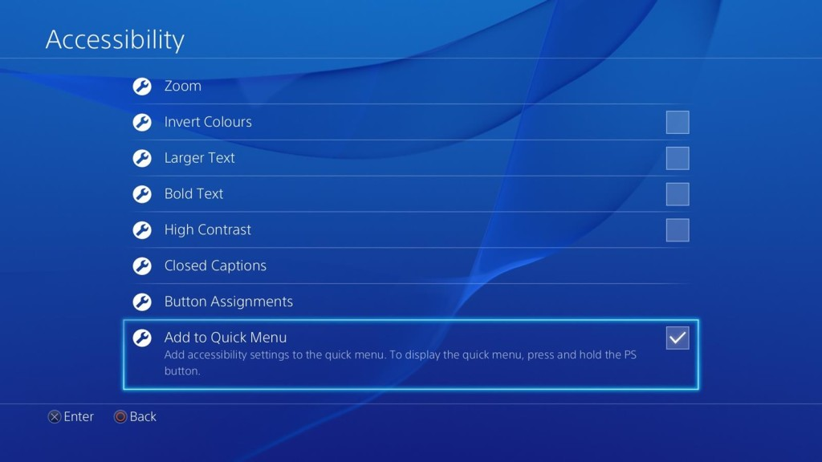
Configurable accessibility quick menu shortcuts on PS4

Do not rely on speech / motion / touchscreen alone for any commands
Simple digital on/off inputs are the most accessible, both directly in terms of motor demands and indirectly through compatibility with the widest range of alternative input devices.
Always have basic controller input as a backup for people who can’t use more complex methods of input, avoid any functionality that relies solely on complex analogue movement, gestures, motion detection, or speech.

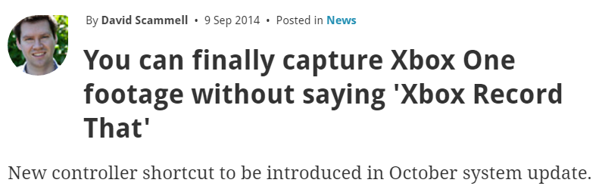
Xbox One patch introducing controller shortcut for functionality previously only available via speech

Associate accessibility preferences with profiles rather than devices
Useful for catering for different people with different needs using the same console, not just in homes but particularly in accessibility heavy environments that have many users per device, such as hospices.
Preferences saved to profiles also allows preferences to roam between devices. Even roam between platforms, e.g. PS4 <-> vita, XB1 <-> windows.

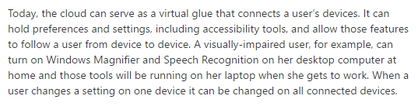
Shared accessibility preferences across Windows devices

Information and configuration during initial console setup
The ability to change console settings – high contrast, text to speech etc - before initial setup, including audio prompt to turn on text to speech, allowing independent use from the outset. This would also be an ideal point to educate first time users about what kind of functionality is available, for example by providing a captioned and audio described overview video.

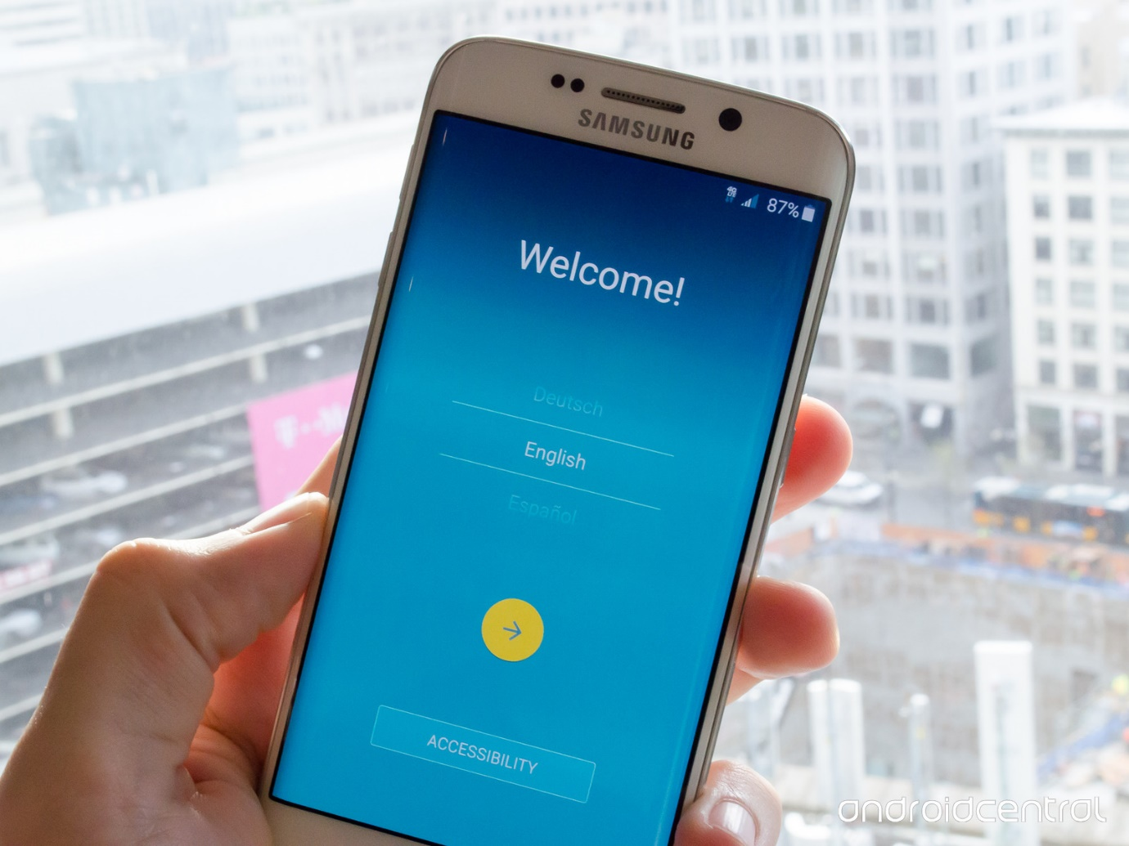
Accessibility configuration available on the first screen of device setup on a Samsung phone

Expose as many system level accessibility preferences as possible to developers
Allow developers to read system level preferences that might be useful in-game (e.g. captions on/off, caption display preferences, text size, high contrast), so they can be pulled into the game as a default value. This is already recommended or required on other platforms.

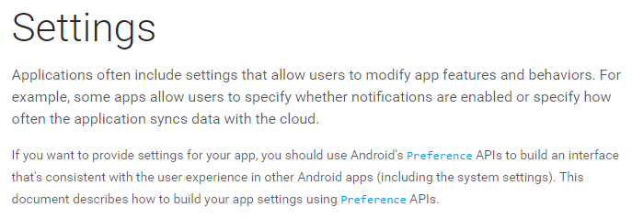
Preference APIs on Android, which include accessibility preferences

Representational avatars / profile pictures
This does not fall under the banner of accessibility, but is something that is still relevant to gamers with disabilities and could be quick and easy to implement, and that has had some heartfelt requests and votes on console forums. A nice way to represent the diversity of the audience, and tie in with the wider inclusivity efforts. Even if it was just a wheelchair to start with (a common request), that’s something that could be built on in future. Consultation is key, for example Xbox’ recent avatar exploration work resulted in some significant and useful public feedback on wheelchair design.

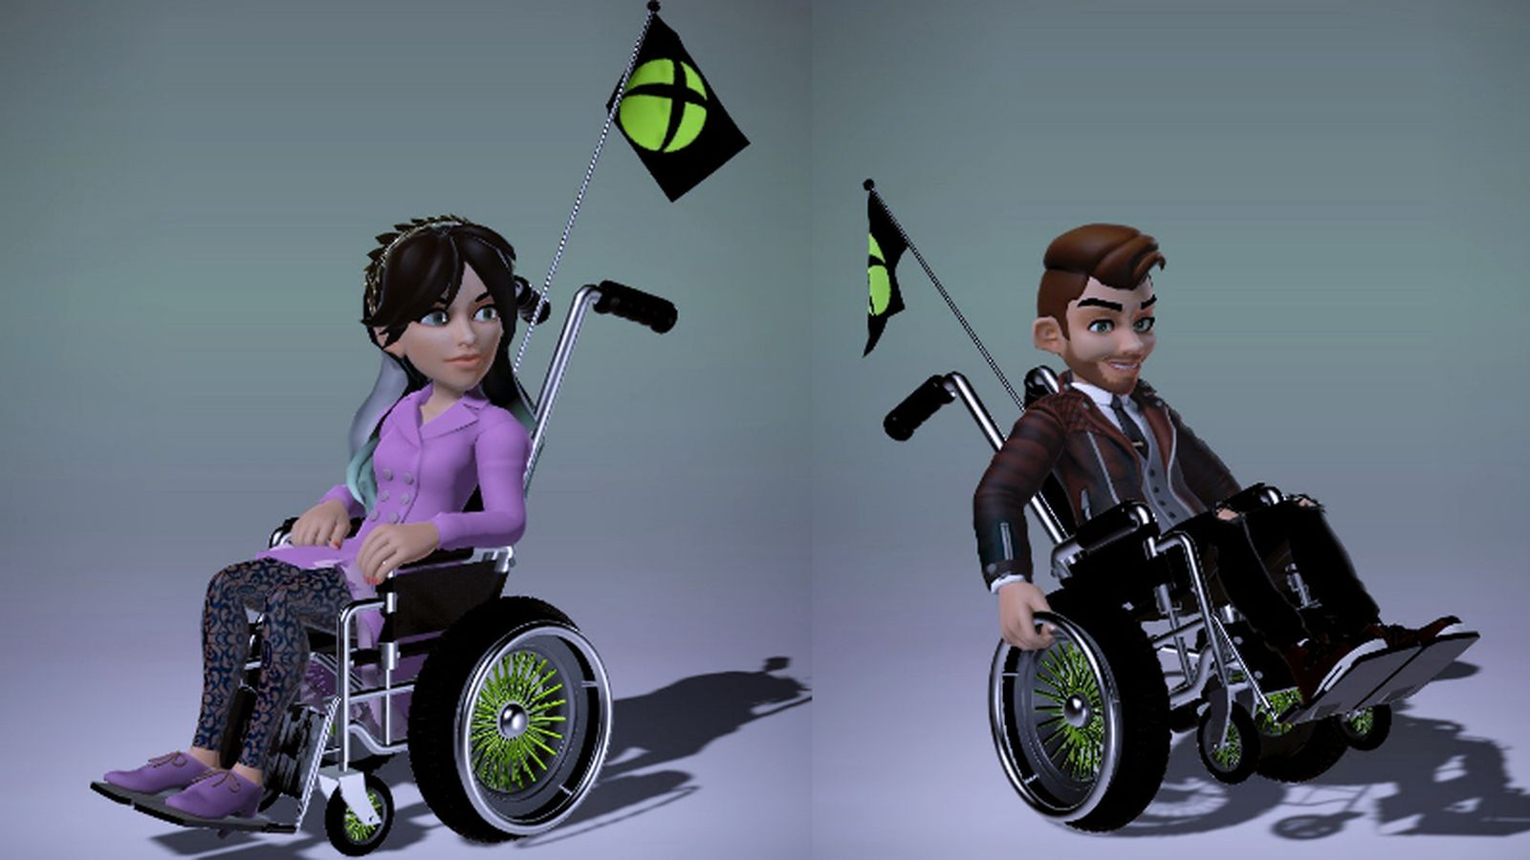
Xbox wheelchair avatars, pre wheelchair design feedback

Provide well publicised direct route for accessibility feedback on console functionality
Knowing where to direct feedback to is a frequent barrier and source of frustration. Some platforms do offer a direct route for feedback, but these need to be very well publicised, ideally with a direct link from the console OS itself.
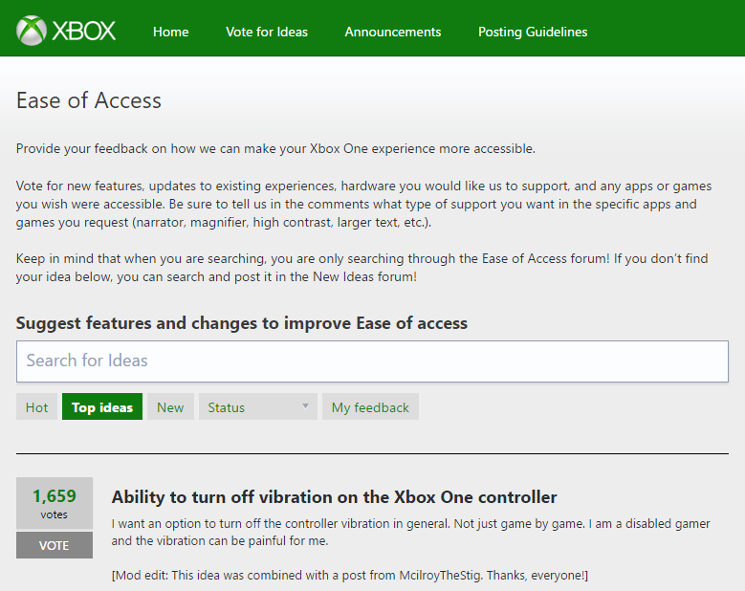
Xbox ease of access uservoice forums

HARDWARE

Enable compatibility with as wide a range of input devices as possible
Motor impaired gamers often rely on third party input devices, including custom one-off and unlicensed products. If a type of input is not provided by the manufacturer, it should be possible for a user to fill the gap themselves.
Enable compatibility with a wide range of input devices, not just unlicensed third party of custom variants of standard controllers, but also keyboards and Bluetooth accessibility switches.
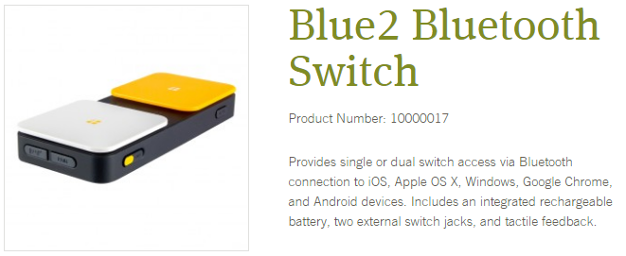
A Bluetooth accessibility switch interface

Backwards compatibility
Assistive technology and custom controllers are usually not mass market products, they have less economy of scale so can be prohibitively expensive. Wherever possible, allow backwards compatibility with controllers from previous console generations. This allows expensive assistive tech to be reused for new generations of console hardware.
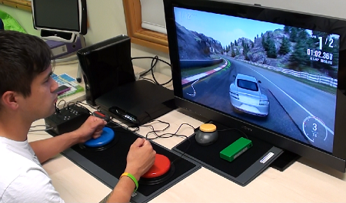
Adroit switchblade modular controller for PS3/Xbox 360, $399 + cost of custom inputs

Compatibility with hearing aids and headphones
Allow a means for hearing aids to connect directly, for example via Bluetooth, to allow audio to be transmitted directly to the device without interference from environmental audio.
For communication that requires use of a device that transmits directly to the ear, e.g. a headset, hearing aid compatibility is a legal requirement.
Similarly, where hardware includes an integrated speaker, ensure the audio can also be accessed through plugging in headphones. If this has potential to apply to any communications related audio, headphone connection must be through an industry standard (i.e. non proprietary) connection.
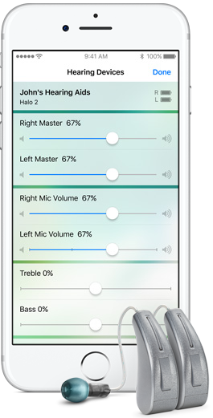
iOS hearing aid support

Develop modular easily customisable controllers
Developing niche controllers for individuals and individual conditions is unlikely to be a viable business model, but if controllers are designed to allow some degree of customisation, including the ability to replace one or more inputs with custom external switches (a wide range of on/off input devices, from large buttons to infra-red blink detectors, that all use the same standard mini-jack connection), players are free to develop their own unique solutions to best meet their needs.
This is currently only possible through bespoke modding, which is expensive and unavailable to many gamers. If more flexibility was introduced at a manufacturer level, the cost and difficulty would be drastically reduced.

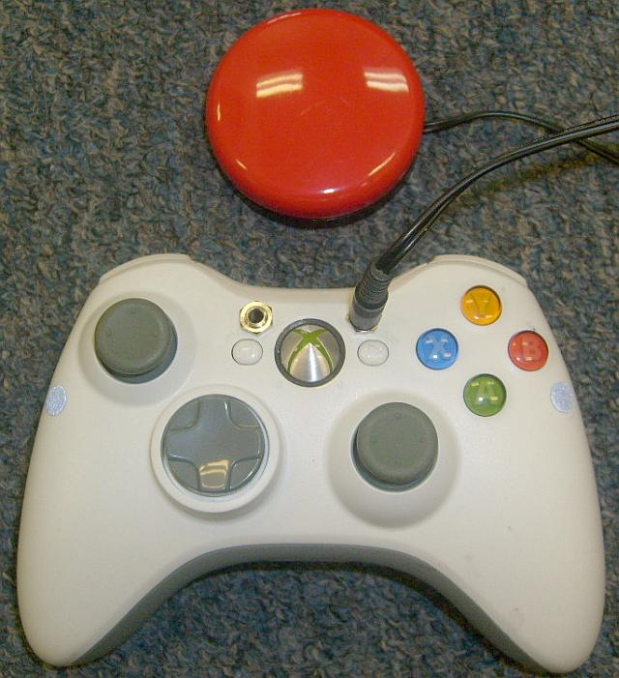
An Xbox 360 controller with a bespoke modification to allow accessibility switches to be connected in place of inaccessible triggers
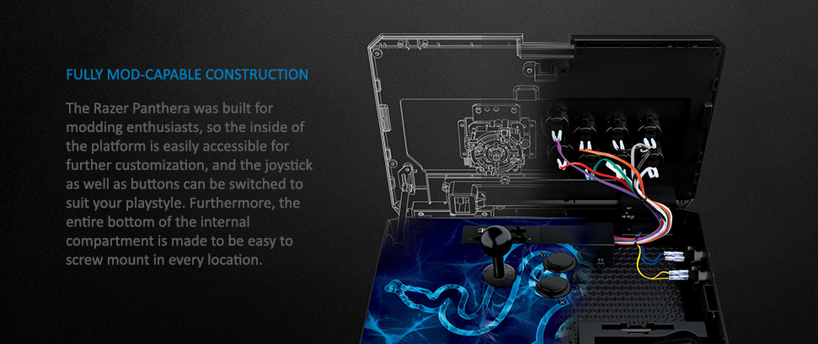
Modification-friendly Razer Panthera controller

GAMES

Require basic common considerations in certification requirements
The vast majority of accessibility considerations in games must be evaluated on a per-game basis. By definition games must involve some degree of challenge, some set of necessary barriers, and what constitutes necessary/unnecessary is entirely dependent on the mechanic of that game. So what constitutes a reasonable set of considerations to aim for is also entirely dependent on the mechanic of that game.
There are however a small number of considerations that can reasonably apply across most if not all games. For example subtitling of all speech, using a minimum text size of 46px for subtitles and 32px for all other text, offering both voice and text chat.
Implementing a small number of core accessibility considerations as certification requirements would not only have a dramatic direct impact on the level of accessibility in games, it would also reduce developer costs through providing extra motivation for engine developers to develop engine level functionality to cater for it.
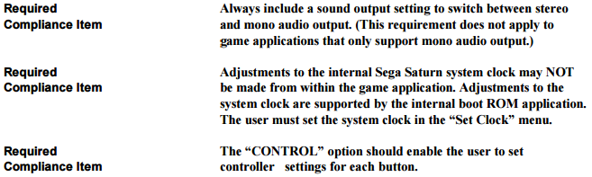
Sega Saturn certification requirements for mono/stereo audio toggle and full button remapping

Encourage consideration of broader accessibility guidelines
Although wide scale accessibility requirements are neither realistic or desirable for the above reasons, platform holders are still in a strong position to encourage their uptake, particularly with first party studios.
This could be approached in a number of ways:
- A general recommendation or requirement that best practices (either internal, such as the BBC’s guidelines, or public, such as www.gameaccessibilityguidelines.com) should be considered, and implemented wherever reasonably possible
- Simple awareness raising that these best practices exist
- Providing advice on accessibility workflow and processes
- Requiring accessibility information as part of certification submissions process. A proven model is to ask if accessibility is being considered, if the answer is yes, ask in which ways, and if no, ask for the reasons why not. This, combined with examples of the kind of features considered, has been both effective and well received by developers as part of the Film Victoria funding programme
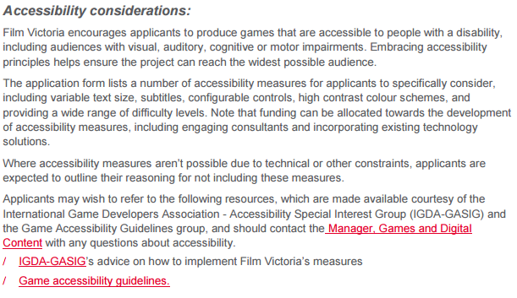
Film Victoria’s accessibility criteria as part of their submissions process

Accessibility information / filtering in the store
Adding some indication of common accessibility features to game descriptions and some way of filtering based on this information would be extremely valuable.
This has started to happen already on some storefronts. As a result, work is currently underway on evaluating what best features to include would be, and how best to word them.
Until then, below is a general proposal of how the functionality could work. It is based on a core set of checkbox features together with a free text field for more details or anything else not covered by the checkboxes, and the data from the checkboxes used to enable filtering of game listings.

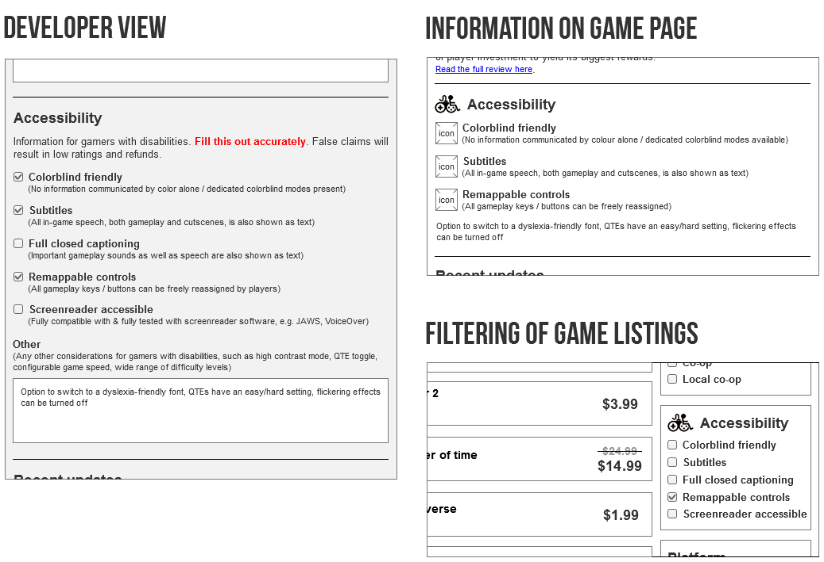
Example of how storefront information could be implemented

Accessibility information on packaging
Include similar information to the above on the back of packaging, in the same way as information on number of players supported, install space, microphone requirement, age rating and so on.
Space is obviously more of an issue on physical packaging than when distributing digitally, but even just information on a few key features such as remappable controls or subtitles could go a long way.

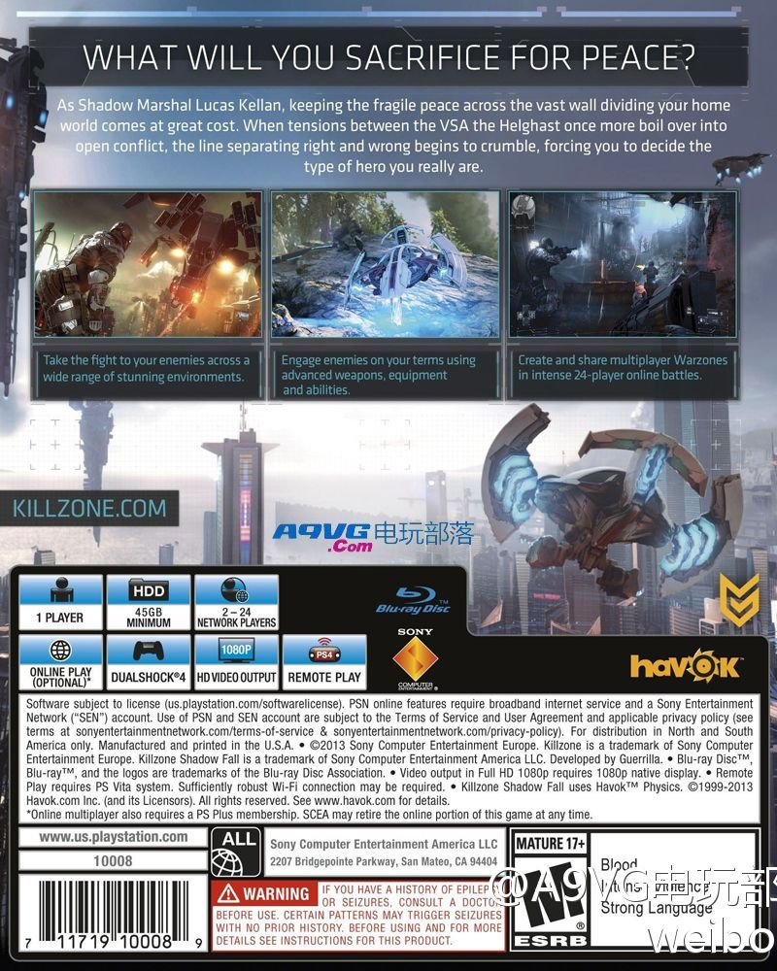
Existing packaging information on Killzone PS4

Provide direct route for gamers to get in touch with developers
As with routes of feedback on console accessibility, knowing how to get in touch about accessibility information on games is a common source of frustration, particularly as gamers do not always understand the platform/publisher/studio relationship, let alone first/third party studios and so on.
So providing a well-publicised high level service to gather accessibility feedback at a platform level and ensure it reaches the right teams would be extremely valuable.
Providing a means of contacting developers directly through digital storefronts would also help.
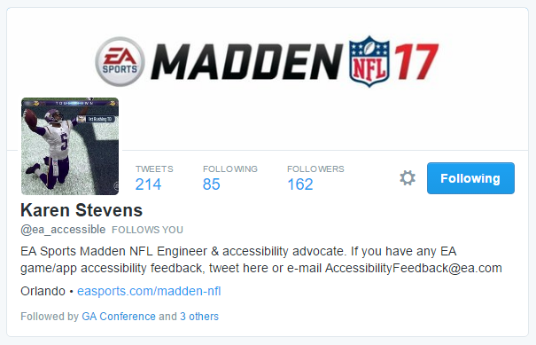
Electronic Arts’ accessibility feedback twitter account

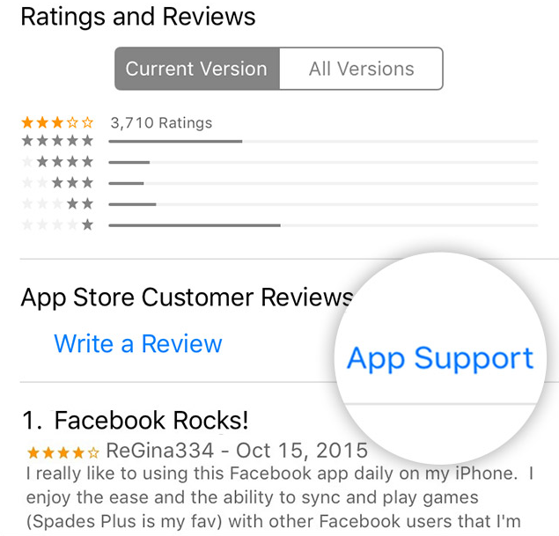
App support link on iTunes

